Alert Watch and Response Engine (AWARE)

User Guide

for

Alert Viewer



July 2015

Prepared by Harris Corporation

CLIN 0007AC

Revision History

| Creation Date | Version No. | Description | Author(s) | Reviewer(s) | Review Type | Issue Date |
| --- | --- | --- | --- | --- | --- | --- |
| 02/13/2014 | 0.01 | Initial | B. Tjahjo | G. Welch S. Wang S. Greenacre M. Becker | Peer | 05/29/2014 |
| 08/27/2014 | 0.02 | Updated all screen shots; Added Original Alert Type in Table 1.  CLIN 0007AC added to cover sheet indicating, per VA PMO concurrence, that deliverable satisfies contractual requirement for System Administration Manual. | B. Tjahjo |  |  | 09/04/2014 |
| 05/01/2015 | 0.03 | Updated Figures 2, 3, 9, 10, 11, and 12 to reflect current version.  Updated Table 2.  Remove “Cache” from Alert Cache Viewer.  Updated Section 2 with the VEFA AWARE OWN ALERT CHACHE key. | B. Tjahjo S. Greenacre |  |  | 07/20/2015 |
|  |  |  |  |  |  |  |
|  |  |  |  |  |  |  |
|  |  |  |  |  |  |  |

Table of Contents

1 Introduction 1

2 VistA Security Key 1

3 User Instructions 1

3.1 Logging in and Starting Alert Viewer 1

3.2 Alert Viewer List Page 2

3.2.1 Service Filter 3

3.2.2 Clinic Filter 4

3.2.3 Ordering Provider Filter 4

3.2.4 Patient Filter 5

3.2.5 Follow-Up Filter 5

3.2.6 Page Navigator 6

3.3 Alert Detail Page 6

3.3.1 Navigating the Tabs 6

3.3.2 Return to Previous Page 6

3.3.3 Alert Fields Definition 7

4 Terms, Acronyms, Abbreviations, and Definitions 10

List of Figures

Figure 1 - Enter URL 1

Figure 2 - Login Page 2

Figure 3 - List Page 3

Figure 4 – Service Filter 3

Figure 5 – Clinic Filter 4

Figure 6 - Ordering Provider Filter 4

Figure 7 - Patient Filter 5

Figure 8 – Follow-Up Filter 5

Figure 9 - Page Navigator 6

Figure 10 – Alert Tab in Alert Detail 6

Figure 11 – Status Tab in Alert Detail 7

Figure 12 – Result Tab in Alert Detail 8

Figure 13 – Follow-Up Actions in Alert Detail 9

List of Tables

Table 1 – Alert Tab Definitions 7

Table 2 – Status Tab Definitions 8

Table 3 – Result Tab Definitions 9

Table 4 – Terms, Acronyms, Abbreviations, and Definitions 10

# Introduction

This document explains how to use the Alert Viewer. The Alert Viewer is a web application designed to be used with the Alert Watch and Response Engine (AWARE).

The AWARE Alert Viewer displays the contents of the Veterans Health Information Systems and Technology Architecture (VistA) VEFA AWARE Alert Cache file. With the appropriate key, a user can see his/her own AWARE Alerts (or with the proper access, all AWARE Alerts). In addition, all physician providers by default can see his/her own aware ALERTS.

Entries in the AWARE Alert Cache file are populated by a VistA TaskMan process (VEFA AWARE ALERT CACHE BUILDER). The data is updated every time this Task runs and is usually scheduled to run every 60 seconds. This process collects all alerts tracked by AWARE Alerts and stores them in the Alert Cache file.

Only the last 14 days of the most recent AWARE alerts are maintained. This can be changed by updating the CACHE WINDOW field of the VEFA AWARE ALERT PARAMETER file.

This document is intended for clinicians, and other personnel such as Department of Veterans Affairs (VA) facility patient safety officers.

# VistA Security Key

To be able to view the entire Alert Cache, a user must be assigned one the following VistA security keys:  
**VEFA AWARE ALL ALERT CACHE**

Users holding this security key may view all alert cache information.

**VEFA AWARE OWN ALERT CACHE**

Users holding this security key may only view AWARE Alerts where they are the patient’s Ordering Provider.

It is the responsibility of Clinical Application Coordinators (CACs) or administrators to assign users with their appropriate key.

The Alert Viewer is also designed to allow users (providers) to view his/her own alert cache information. Also by default, any physician user with a Drug Enforcement Agency Number (DEA#) is permitted to view patients in his/her alert cache.

# User Instructions

## Logging in and Starting Alert Viewer

The Alert Viewer can be accessed using the following URL:  
http://<HostServer>/csp/aware/alertcache/alertcache.csp

<HostServer> is the Fully Qualified Domain Name (FQDN) of the web server or IP address where the Alert Viewer is hosted.

Enter URL

Figure 1 - Enter URL

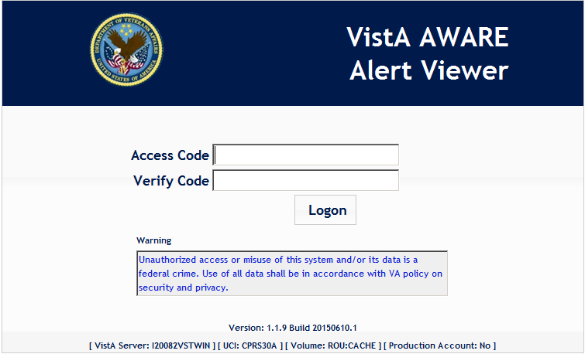

Figure 2 - Login Page

The first page of the Alert Viewer is a login page. The user must provide his/her VistA user Access and Verify code and click the Logon button to log into Alert Viewer.

## Alert Viewer List Page

After successful login, AWARE Alerts will be displayed. The user’s security key will determine which alerts are shown.

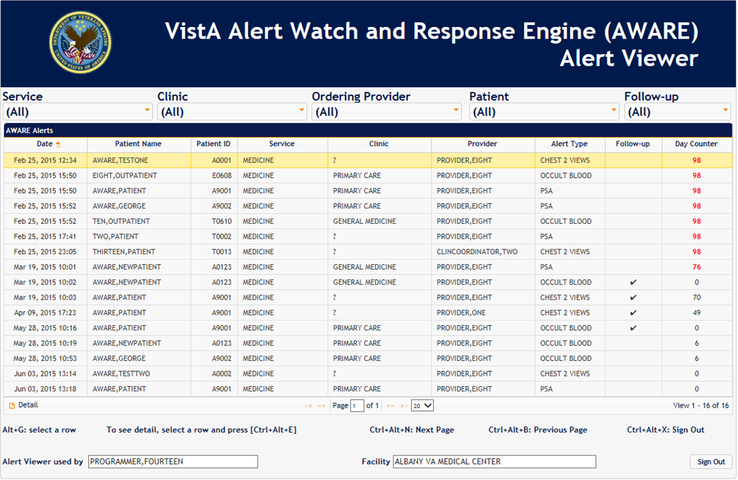

Figure 3 - List Page

The list page is a table showing AWARE Alerts. Five filters can be used to change what is shown.

### Service Filter

Service is the first filter of a series of multi-select filters in Alert Viewer. The user can select one or more services to filter the list view. Only alerts for those selected Services will be displayed.

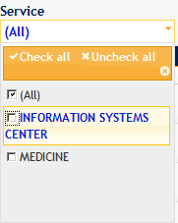

Figure – Service Filter

### Clinic Filter

The user can further filter the list view by selecting one or more clinics. Only alerts for those selected clinics will be shown.

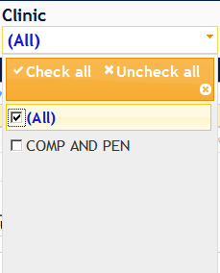

Figure – Clinic Filter

### Ordering Provider Filter

This multi-select filter is only available for users with the VEFA AWARE ALL ALERT CACHE key. Selecting providers from the list will populate the grid with alerts owned by those providers.

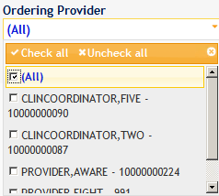

Figure 6 - Ordering Provider Filter

If the user does not have the VEFA AWARE ALL ALERT CACHE key, this filter will not be an option and only alerts belonging to the user will be displayed.

### Patient Filter

By using the Patient Filter, the user may view alerts for selected patients, or leave the setting at “All” to see all patient alerts.

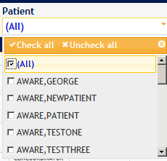

Figure 7 - Patient Filter

### Follow-Up Filter

This filter allows the user to display alerts that either have been followed-up or not by selecting “Yes” or “No”. There is a Day Counter column in the list to indicate how many days it took the provider to follow-up the AWARE alerts or how many days the alerts have not been followed-up.

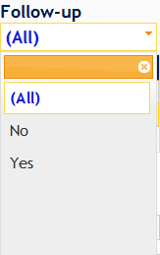

Figure 8 – Follow-Up Filter

**Keyboard Navigation on Multi-Select box:** While on the select box, use the [Enter] key to list all available items in the multi-select box then use the [Down] and [UP] arrow keys to navigate through the list and press [Enter] to select any items available. Use [ESC] key to exit from the selection.

**Sign out Button**: User may logoff from Alert Viewer by clicking the Sign Out button (on the bottom right corner of the page) or use a keyboard shortcut Ctrl+Alt+X. This action will clear the session and cookies associated with Alert Viewer.

**View Detail Information:** The list page shows an overview of the AWARE Alerts. To see all field values for record, the user may view detailed information by selecting an item in the list then pressing the Enter key, or by double-clicking the selected item, or by clicking on the Detail button.

### Page Navigator

On the bottom of the grid, there is a page navigator.

By default, 20 records per page will be populated on the grid. Users can change the amount of records that are displayed by selecting how many records should be displayed from the drop down list. This selected size is “sticky” meaning that it will stay the same for the next session.

Users can navigate to different pages by entering page numbers or by using the Next, Previous, First and Last buttons.

Page Navigator

Figure 9 - Page Navigator

## Alert Detail Page

Alert Detail information is divided into four tabs as shown below.

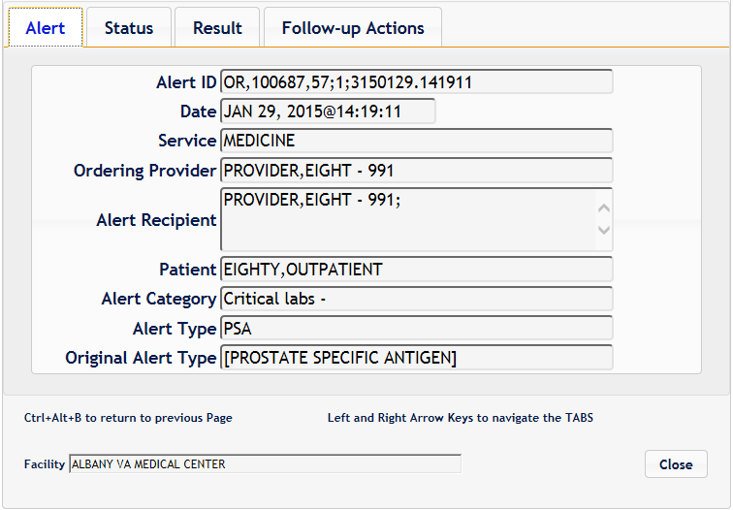

Figure 10 – Alert Tab in Alert Detail

### Navigating the Tabs

Use the Right arrow key to navigate to the next tab and the Left arrow key to navigate to the previous tab.

### Return to Previous Page

To return to the previous page (List Page), use the Close button or the keyboard shortcut Ctrl+Alt+B.

### Alert Fields Definition

As previously stated, the AWARE Alert records are populated by a VistA TaskMan process (VEFA AWARE ALERT CACHE BUILDER). This process collects all alerts from file #8992.1 (Alert Tracking) that are tracked by AWARE Alerts and stores the alert information into file #19008.2 (Alert Cache).

The following fields in the tabs below are the alert information stored in the Alert Cache file.

Table 1 – Alert Tab Definitions

|  |  |
| --- | --- |
| **Alert ID** | The Alert Tracking Name field (File #8992.1, field .01) |
| **Date** | The date and time the alert was sent/forwarded |
| **Service** | The name of the service or section for the Alert Recipient |
| **Ordering Provider** | The provider who generated the alert by prescribing the order |
| **Alert Recipient** | The recipients of the alert such as Ordering Provider, Lab Tech, Radiologist, OR/RR Team |
| **Patient** | The Patient name indicated by the Alert |
| **Alert Category** | Alert name contains notification type value. This is the Alert Category with the notification type. Alert Category is defined in KB Editor. |
| **Alert Type** | This is the Generic Alert Type Name defined in KB Editor |
| **Original Alert Type** | The Alert Type name stored in Alert Display Text defined in KB Editor |

The following images display the rest of the tabs in the Alert Detail.

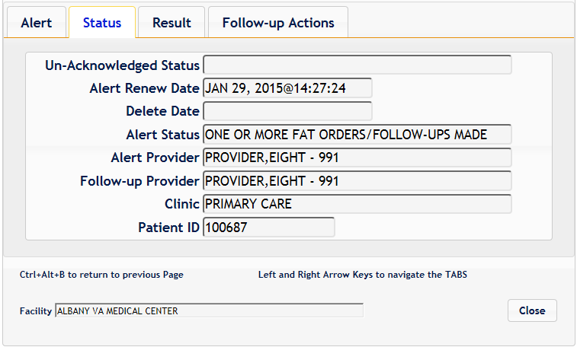

Figure 11 – Status Tab in Alert Detail

Table 2 – Status Tab Definitions

|  |  |
| --- | --- |
| **Un_Acknowledged Status** | This status indicates whether the Alert has no Processed Alert Date and Deleted Date. |
| **Alert Renew Date** | This date identifies the renewed date for needed acknowledgement after no follow-up action taken has been determined upon provider processing of the alert. |
| **Delete Date** | The Alert Deleted Date (date of acknowledgement) |
| **Alert Status** | This field contains the status of whether Follow-up Action Tracking Orders/Follow-ups have been made. |
| **Alert Provider** | If Follow-up Action Tracking Orders/Follow-ups have been made, this field will contain the name of the provider who did required orders/follow-up action(s) defined for this alert type, including the signing of signing required order(s). It also concatenates the providers internal ID (DUZ) at the end. |
| **Follow-up Provider** | This is the name of the provider who does any follow-up action on the alert, and is not necessarily the same person as the ordering provider for the alert. It also concatenates the providers internal ID (DUZ) at the end. |
| **Clinic** | This is the hospital location from which the order originated |
| **Patient ID** | The Patient DFN which indicated by the alert |

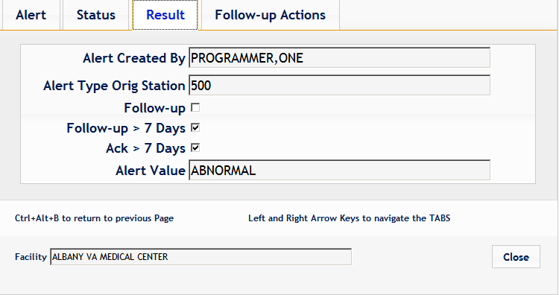

Figure 12 – Result Tab in Alert Detail

Table 3 – Result Tab Definitions

|  |  |
| --- | --- |
| **Alert Created By** | The person responsible for the Alert being created. |
| **Alert Type Orig Station** | The Site number of VA facility where the Alert Type was created and designed in the KB Editor. These Alert type definitions can be used at other sites when these definitions are imported to other sites as is done with the base 4 cancer tracking alert types delivered with AWARE. |
| **Follow-up** | This field indicates whether or not follow-ups have been performed for this alert |
| **Follow-up > 7 Days** | If the follow-ups have been performed within 7 days of the occurrence of the alert, this field will be set. Its value is not determined until after 7 days have passed from the occurrence of the alert. |
| **Ack > 7 Days** | This field indicates whether or not the date of the acknowledgement of the alert is beyond 7 days of occurrence. Acknowledge Date is synonymous with Alert delete date |
| **Alert Value** | This value is a critical abnormal value such as “POSITIVE” or a numeric alert value including critical indicator (such as “H” high or “L” low) for lab alert types, or the phrase “ABNORMAL” for Abnormal Imaging alert types. |

The table in the Follow-up Actions tab shows all order/follow-up actions and the dates when they were performed.

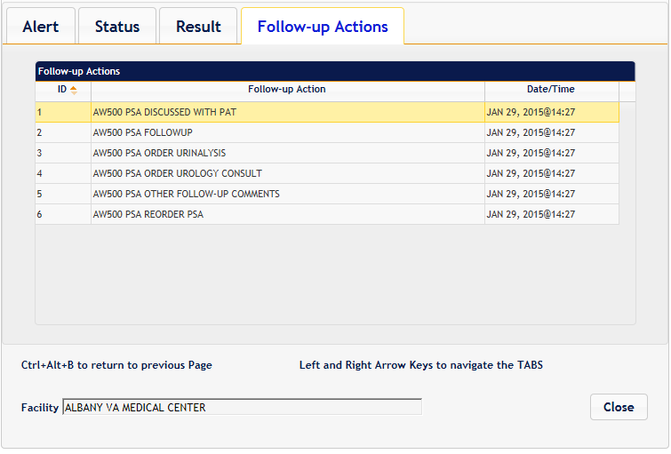

Figure 13 – Follow-Up Actions in Alert Detail

# Terms, Acronyms, Abbreviations, and Definitions

Table 4 – Terms, Acronyms, Abbreviations, and Definitions

|  |  |
| --- | --- |
| Terms, Acronyms, Abbreviations | Definitions |
| AWARE | Alert Watch and Response Engine |
| CAC | Clinical Application Coordinator |
| DEA | Drug Enforcement Agency |
| FQDN | Fully Qualified Domain Name |
| URL | Uniform Resource Locator |
| VA | Department of Veterans Affairs |
| VEFA | AWARE VistA Namespace |
| VistA | Veterans Health Information Systems and Technology Architecture |